

HP Amazon Infographics
Visual Concepts, v1.2
EMEA HP Supplies

02.13.2019

Developed by Yes Marketing

Problems to solve for:
- rapid visual communication
- product features clearly conveyed in language agnostic visuals
- imagery not to include specific products but product families (ex: ink vs. toner) Please clarify. In terms of lifestyle photography, we may avoid specificity in printer/ink/toner products. More ambiguous product imagery will result in more universally applicable infographics.
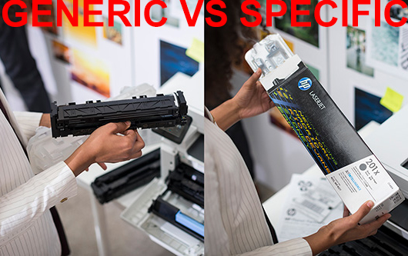
- imagery is exploratory existing in both small and large dimensions. Please clarify. We will optimize infographics to work well within the Amazon UX.
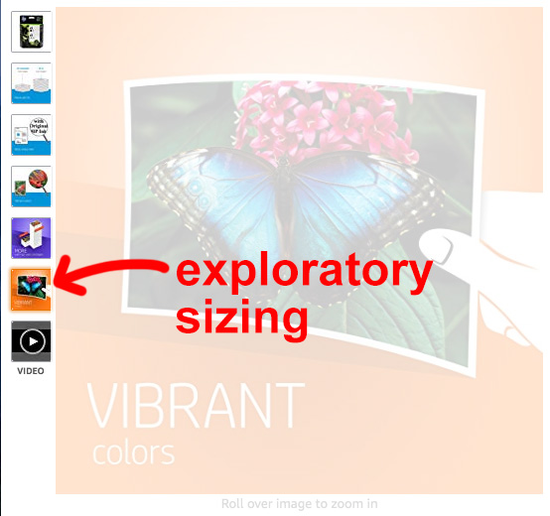
- this system should be expandable to future products
- this system should be consistently formatted

Requirements:
- we should leverage HP owned assets (photography, iconography, fonts) If no HP-owned imagery is found to represent a specific feature, please let us know. We can work with HP Imagery team. Thank you.
- minimal copy (3 to 4 words)
- series of images should tell a story that sells
- focusing on product benefits and features
- minimum 1500px square, 10mb each or smaller. Please follow Amazon guidelines for secondary imagery. Will do.

Vision:
- deliver a tool kit of visual assets
- we envision a lifestyle/icon combo
- explore/incorporate HP color pallet
- graphic treatments to be fully explored in design. Please clarify. We will develop options in art direction during the next phase of this project.

LAYOUT CONCEPT this could work. You can also try other layouts if this ends up being complicated i.e. fitting the lifestyle image in the triangle bottom right can become challenging in some cases… Agreed, initially we must explore multiple layout options.

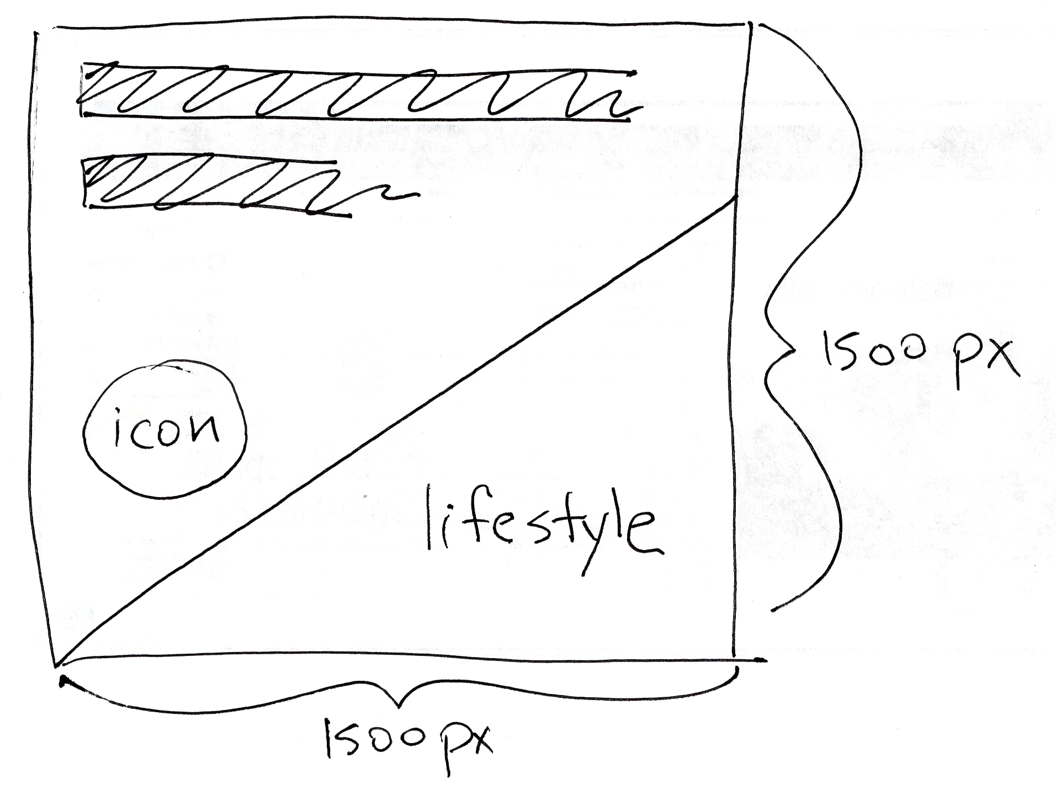
Headlines

Image treatments
(to explore in design)

HP Icons

HP photography

INSPIRATION (w/less copy)
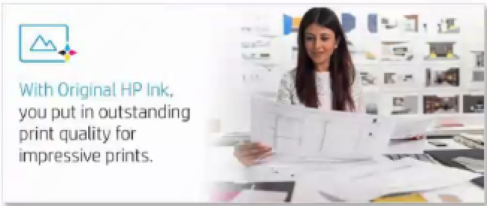

BENEFIT DEFINITIONS
# | Product Benefit | Core Concept Description | Sketched Concept
1. | Color/size/yield (toner)  This design, for both ink and toner, we are willing to communicate the color of the cartridge and the number of pages that you can print with that cartridge. Providing some ideas/concepts at the bottom of this document. What is most important is the page yield. This design together with the Warranty are the only ones that can differ from the rest in terms of layout. | With Original HP cartridges, you get the yield you expect. 21% more usable pages.  Page yield is connected to usability, number of pages possible to print at certain cost of supplies Ensures resource efficiency (circular economy). | 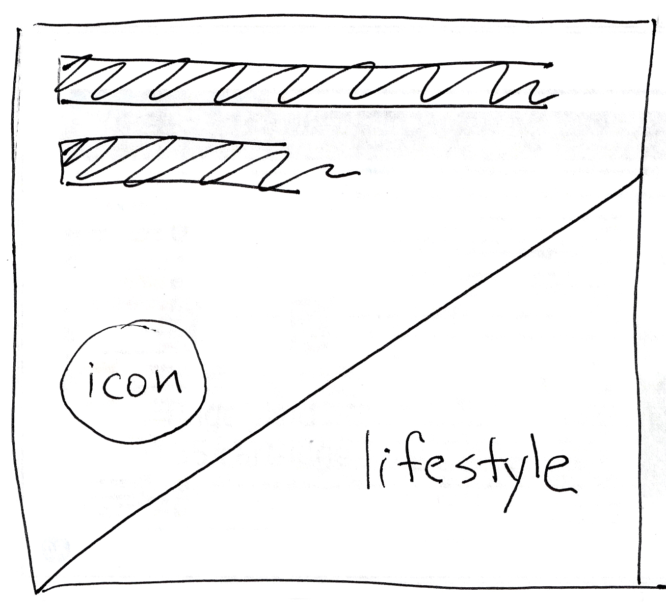
2. | Color/size/yield (ink) | How do ink and toner differ here? The ink liquid and the toner powder images (if you decide to use these) they come in different format/shape. Therefore, the ink and toner color/yield design may require a singular design for each technology.
3. | Warranty (toner) | Up to 2 years. Any other important information? NO! Toner has lifetime warranty. Sorry if it was mentioned 2 years anywhere in my documents. The idea of this design is to show customers that OHP Toner comes with lifetime warranty. Full stop therefore we were thinking in providing a label that would show this. This one doesn’t necessarily need to follow the same layout as the rest. See at the bottom of the document what other manufacturers are doing, these two examples were provided by the EMEA team, saying they would like something similar.
4. | Easy and free recycling (ink and toner) | Cartridge end-of-life and the HP Planet Partners recycling program. No cartridge is sent to the landfill.
5. | % of recycled content (toner) | 100% of Original HP toner cartridges are now manufactured with recycled content.  Recycled content: used HP toner cartridges
6. | % of recycled content (ink) | More than 80% of Original HP ink cartridges are now manufactured with recycled content.  Recycled content: used HP ink cartridges + plastic bottles + hangers
7. | Safe air quality (toner) | Indoor air quality and ecolabel compliance. Proven adherence to health and safety standards. Customer safety, ventilation, substances and particles emissions. EPEAT, Blue Angel, Nordic Ecolabel, and EcoMark. I am investigating if we have the rights to use EPEA/Blue Angel logos/labels. Will let you know.
8. | Bold sharp text (ink and toner)
9. | Vibrant colors (ink and toner)
10. | Reliability (ink and toner) | Designed to work first every time. Consistent print quality for waste reduction. Smaller carbon footprint and less energy consumption. Keep printers running, increase productivity. Less service calls. Correct. Also, can be related to “Better together”. HP Cartridges are designed for HP Pritners so these can work first time every time.  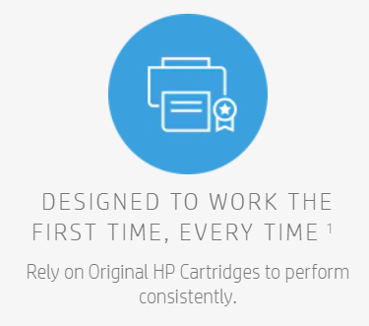  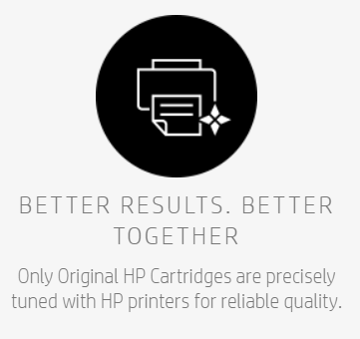
11. | Versatility (ink) | Archivability and durability of printouts. It’s more in the sense that with OHP Inks you can print both documents and photos with the same quality. Our inks are versatile to any usage.

Next steps:
- Gather additonal feedback/insight on 11 infographics (above)
- Gain approval of this document
- Develop multiple design directions for review
- Hold a design presentation call

Warranty label: Ideas from our manufacturers, provided by EMEA
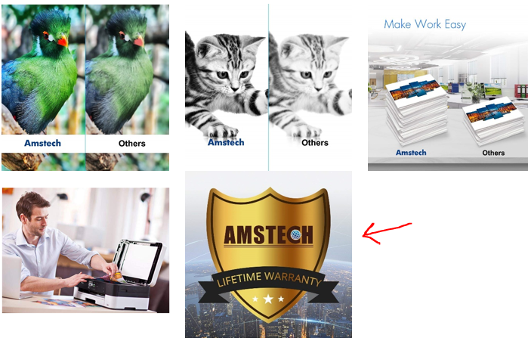

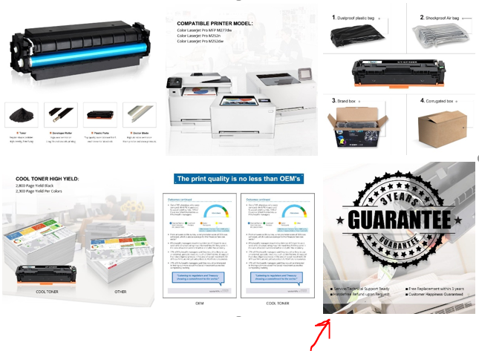

Ideas/concepts for page yield/color design: 